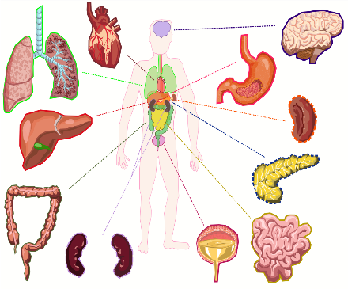**Introduction to Human Anatomy & Physiology I**

Syllabus

Fall Semester September 2021– January 2022

Mrs. Marinucci

kate_marinucci@gateschili.org

Room 339

585-247-5050 x - 73404

**General Course Info:**

Anatomy and Physiology is the study of the *structure and function* of the human body. We will complete many activities (labs, projects, classwork & homework) to reinforce content material. Several projects, a comprehensive lab for each unit, dissections and a final project/exam will all be completed during this semester as well.

This course is designed for college preparation; especially for **Biology and Health Career Majors**. A&P is one of the more challenging Biology classes in college – this course will give you a marked advantage when you enter your collegiate courses. This class will be a blend of fun activities as well as rigorous study of medical and scientific terminology.

**What to Expect:**

Our course will look different than it has in the past. We will still need to adhere to COVID safety guidelines, which may limit what we can do in science with regard to collaborative work and lab materials. All you need to do is try your best. This includes your best effort at working independently when needed, taking part in class discussions, contributing in lab groups (on a limited basis), completing classwork/homework, studying your notes, and reviewing/studying for all tests and quizzes. When you have questions or concerns, I will be available *after school each day per week (Except Tuesday),* I can meet with you in the senior lounge if you are available when I am there, and we can also schedule an appointment outside of that if need be.

**What to Bring:**

These are the things you need to bring to class everyday:

* Laptop (and charger if needed)
* Pen/pencil
* 3 ring-binder (optional)
* Colored pencils (I will have these available in class, but you might want your own)

NOTE: Our course text and notes will be made available on Schoology to reduce the use of shared materials and passing back and forth of papers. There will be times when paper copies will be needed so plan accordingly with writing utensils and folders.

**Grading Policies:**

Unit Exams: 30%

Quizzes: 20%

Projects/Labs: 30%

Homework/class participation: 20%

**Work Ethic:**

* It is expected that you take pride in your work; it is a reflection of you.
* You are responsible for handing in your work on the assigned due date. That applies to hybrid and remote learners.
* When you are working with other students, I expect that your assignments will not be copied; I also will not tolerate allowing others to copy your work. Both parties will receive an automatic zero if copying is observed.
* You will be expected to work on projects both in and outside of class
* Homework or classwork not completed during class is expected to be completed outside of class and turned in promptly the next class.

***Late Labs/Projects:***

* The policy for missed labs is that you have one week to the day of your legal absence to make up that lab. After this point any make-up work will be accepted based on the teacher’s discretion.

***Dissections:***

* At this point in your academic career, you are expected to be an active dissector, not a passive participant.
* All specimens MUST be treated with the utmost respect.
* All lab stations and materials must be left SPOTLESS.

[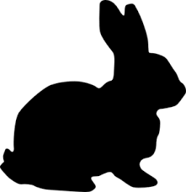](https://www.google.com/imgres?imgurl=http://www.clker.com/cliparts/i/C/W/k/Q/2/rabbit-silhouette-md.png&imgrefurl=http://www.clker.com/clipart-rabbit-silhouette.html&docid=rbRu9-c2ydDspM&tbnid=MiVy1-11i2En5M:&w=291&h=300&safe=strict&bih=856&biw=1280&ved=0ahUKEwj8_YiB3ZjOAhVCaT4KHUMjBfsQMwiSAShRMFE&iact=mrc&uact=8)[](https://www.google.com/imgres?imgurl=http://images.clipartpanda.com/dog-and-cat-silhouette-clip-art-free-slinky_cat_0071-1002-1223-4664_SMU.jpg&imgrefurl=http://www.clipartpanda.com/categories/dog-and-cat-silhouette-clip-art-free&docid=MdIlt-Rhinx7eM&tbnid=iNdq1fOtnK6MAM:&w=300&h=210&safe=strict&bih=856&biw=1280&ved=0ahUKEwjttubb3JjOAhUFFz4KHXbQBQgQMwhTKBYwFg&iact=mrc&uact=8)

**Lab Report Breakdown:**

All labs will be evaluated on a 50-point scale taking into consideration the following:

*Handed in on time* = **5 pts.** ________

*Neat and thorough, all sections complete* = **10pts.** ________

*Accurate data, graphs, measurements, diagrams* = **15pts.** ________

*Post Lab analysis questions answered* = **10pts.** ________

*Lab performance* = **10 pts.** ________

*(Followed directions Worked safely Stayed on task*

*Actively engaged, i.e. - not letting one person do all the work)*

**Schoology:**

The schoology platform will be used this year to provide a central location where all learners will have access to materials in and out of class. The goal at this time is to put each day’s lesson and handouts in schoology with instructions on what to complete for that day. Students in the classroom will receive these instructions in class, while students who may be absent can still access materials from home. NOTE: remote live instruction is not being used at this time.

Folders will be set up for each unit in class so students can easily access the location and materials for the day (see below):

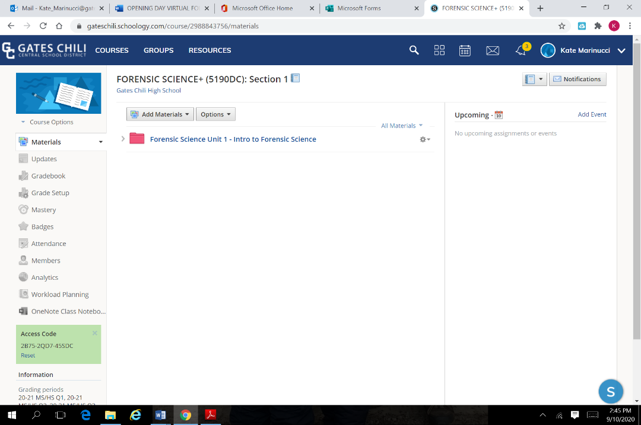

**Classroom Code of Conduct:**

My goal as a teacher is to create a comfortable learning environment. My rules are quite simple and follow this basic philosophy: **treat other people the way you expect to be treated**. This goes for every person in the room or working from home. You will need to collaborate with others in throughout the course of the class, so the expectation is that you will be mature and respectful to your classroom colleagues.

Please treat the equipment in the classroom with respect; do not draw on the lab desks or tables or do anything that will deface or damage equipment. Please use all lab supplies appropriately; when in doubt ASK! Make sure all glassware and instruments are clean and dry before they are returned; please do not leave anything in the sinks, including tissue from specimens.

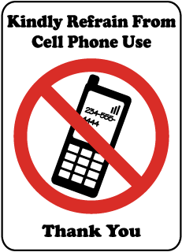**Cell phones, MP3 players, Tablets:** It is flat out **rude** to use your cell phone or device **during instruction** in any class unless directed by the instructor, or at times when a peer is speaking or collaborating with you. We must rely on technology more so this year than in the past, but we must use it appropriately.

If you are using your phone at an inappropriate time, or using your personal laptop device inappropriately, you will be asked to leave class. If asked to leave, you will not receive credit for your work in class for that day. If you need to be spoken to again about this again, you will receive a referral. As much as we all love the convenience of the world at our fingertips, there is a time and a place for cell phone use.

**Tardiness:** Please come to class and lab on time. I will expect a pass if you are late. **After 3 lates with no pass each subsequent late will receive a referral.** Any work missed when you are late without a pass will count as a zero

**Skipping Class:** All work missed is automatically a zero and a referral will be written. If for any reason you cannot attend class while you are at school (eg. Field Trips, Testing) please let me know ahead of time where you will be.

**Absences:**

When you are absent, please check the make-up work folder with your class period on it for your missed work (in case we have hard copies handed out), or your class schoology folder online. It will have your name on it! I will not remind you to do this after the first few weeks, so please keep this in mind if you are absent. You are also responsible to catch up on your notes by either borrowing notes from a classmate. **I will not remind you to catch up on work you have missed – this is your responsibility!**

[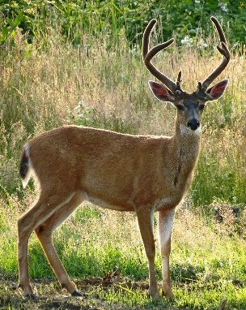](https://www.google.com/url?sa=i&rct=j&q=&esrc=s&frm=1&source=images&cd=&cad=rja&uact=8&ved=0CAcQjRxqFQoTCOqp0sj8gMcCFQV4PgodBZQAWQ&url=https://srichinmoy.wordpress.com/2013/12/22/animal-kingdom-16-deer-speed/&ei=1xu5VariHIXw-QGFqILIBQ&bvm=bv.99028883,d.cWw&psig=AFQjCNEIiA3aLLK5ei1VSB9RNDxx3iarTA&ust=1438281031372659)

**\*\*HUNTERS:** I will give you extra credit for frozen, non-decomposed organs. Please do not wash the blood off of the organs or store them in water. I would LOVE hearts connected to the lungs as well as kidneys (with adrenal glands and fat capsule intact, if possible.) Our opportunities to dissect this year may be limited but if you do hunt and are able to bring in a deer heart, it makes for a really cool demonstration.

**\* ANOTHER IMPORTANT NOTE:**

*Course content, sequencing, lab opportunities, and/or resources may change due to the nature of the COVID situation. Students will be made aware of changes as they happen and allowances made wherever possible. Thank you for your patience and understanding during this time.*

**Topics of study**

Topics we will investigate in the first half of this year will include:

* **Body system organization and anatomical terms**
* **Cell structure and function review and tissue histology**
* **Skin, muscles and bones (a brief overview)**
* **Blood and the Cardiovascular system**
* **Urinary System**

Should you continue your study in Anatomy and Physiology II, topics will include:

* **Nervous system**
* **Endocrine system**
* **Integumentary system**
* **Digestive System**
* **Reproductive system (time permitting)**

**Student Agreement**

For your first homework completion grade:

Open this document in schoology, type your full name, today’s date and “I agree” next to the date as shown below. This constitutes your electronic signature. By “signing” that you have read this syllabus through, you are acknowledging that you agree to follow in-class, or remote guidelines. Once you have agreed, submit your document into schoology.

For a bonus point on your first assignment, click on the link below and read through the details of some healthcare related careers. Choose one that you find interesting, and write a couple sentences as to why you might enjoy a career like that, and whether or not you have a healthcare career in mind or not. Add your answer below your signature in the electronic document:

E-Signature: Quang Huynh Date: 9/9/21 (I agree/do not agree)

I agree

Link:

<https://www.cnbc.com/2019/05/10/14-high-paying-healthcare-jobs-you-can-get-without-an-md-or-phd.html>

One interesting career that I found was an occupational therapist. I find it interesting due to the involvement of physical activity and socializing. Furthermore, I get the satisfaction at the end of the day because I got to assist somebody’s physical body, movement, socialization, or dexterity. Moreover, I don’t have a healthcare career in mind, as I don’t have a plan for my future yet. I am thinking about being a psychologist or doing a STEM major.